AI AGENTS & RAG · LESSON 1 OF 3
Building RAG with n8n
Lesson 1 — Connect, Authenticate and Find a Real File
STUDENT LAB MANUAL

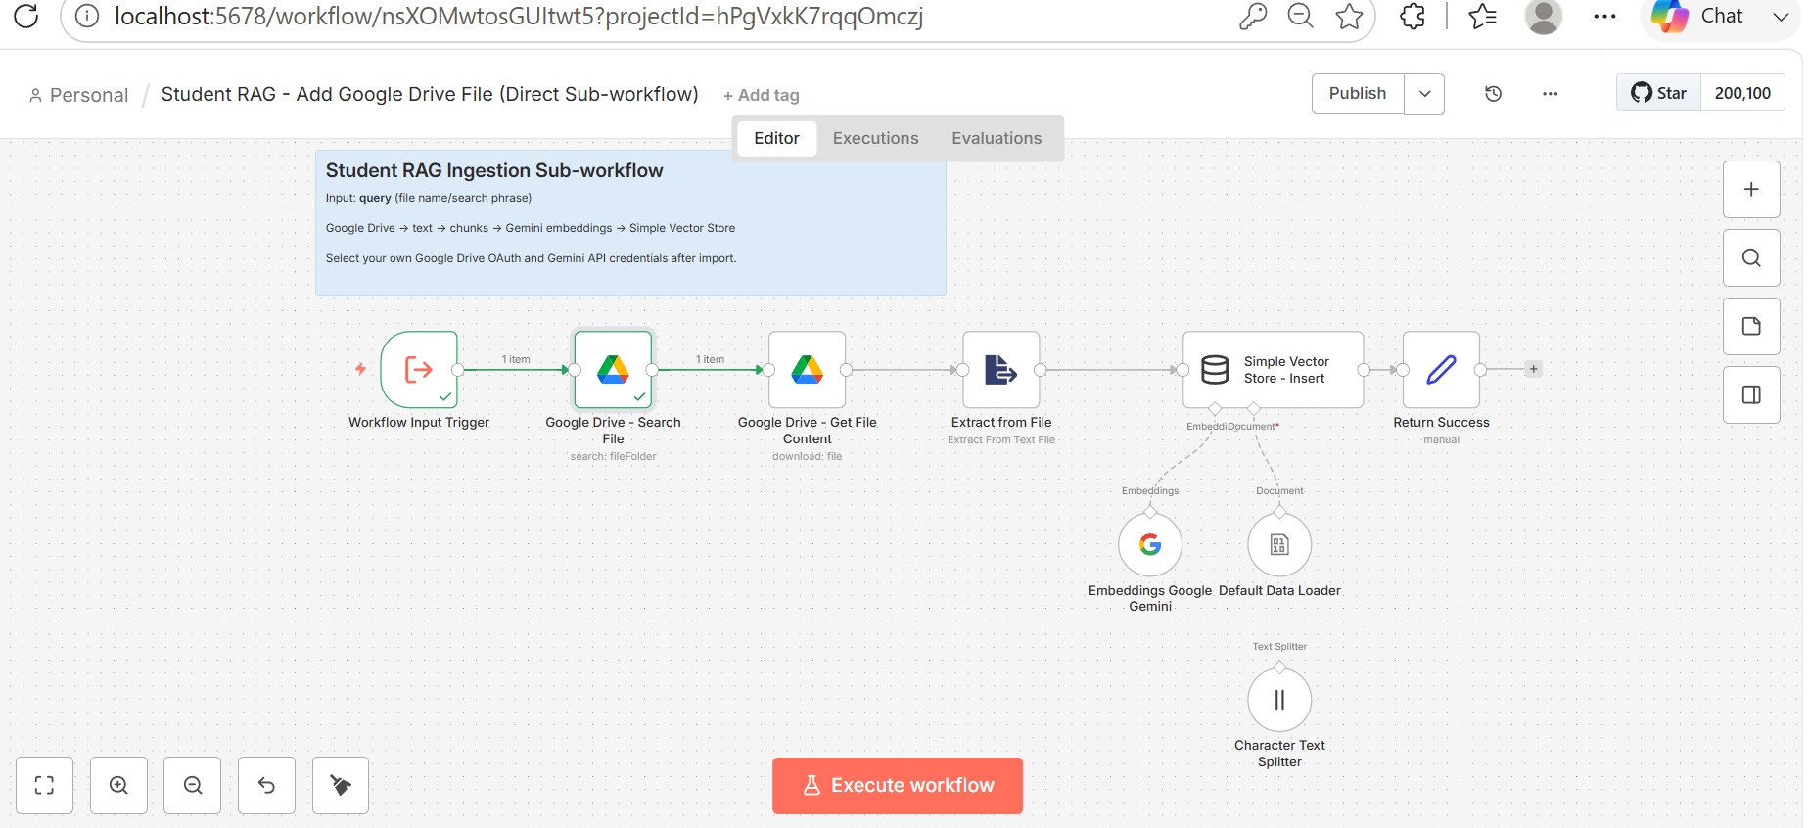
Figure 1. The complete n8n workflow you will import. In Lesson 1 you only run the first two nodes — the rest waits for Lesson 2.

Course | Artificial Intelligence Training Program — Data Science Academy
Module | Module 6 — AI Agents and Retrieval-Augmented Generation
Level | Beginner. No programming experience required.
Duration | 120 minutes — 30 min theory, 75 min hands-on lab, 15 min checkpoint
You will need | A Google account, a browser, and access to n8n (cloud or local)

Contents

Lesson at a Glance 3
Part 1 · What You Will Be Able To Do 4
Part 2 · The Theory You Need First 5
Part 3 · Before You Start 13
Part 4 · The Lab, Step by Step 15
Part 5 · Troubleshooting Guide 33
Part 6 · Lesson Checkpoint 35
Part 7 · Quick Quiz 36
Part 8 · Homework 38
Part 9 · Glossary 40
Part 10 · What Comes Next 42
Appendix A · Workflow Node Reference 43
Appendix B · The Sample Knowledge Document 44

NOTE
How to use this manual. Read Part 2 before class or in the first half hour — the lab makes much more sense once the vocabulary is familiar. Then work through Part 4 at your own pace. Every step ends with a short check so you always know whether to continue or stop and fix something. If a step fails, go straight to Part 5.

Lesson at a Glance
This lesson has one practical goal and one conceptual goal, and they support each other.

 | What it means
The conceptual goal | Understand what Retrieval-Augmented Generation is, why an AI model needs it, and what the words document, chunk, embedding, vector store and semantic search actually mean.
The practical goal | Connect n8n to your Google Drive securely, then prove the connection works by finding a real file and reading back its Google Drive file ID.
Why they belong together | A RAG system is only as good as its access to your documents. Before anything can be retrieved, something has to be allowed to read it. That permission bridge is what you build today.

SUCCESS CRITERION
You have completed Lesson 1 when the Google Drive – Search File node in n8n returns a result that looks like this:

[
{
"id": "1Q1RuGYHSrAGb1Q4i44MuI3naqI9dfkKn",
"name": "University_AI_Course.txt"
}
]

Your id will be different from the one above — every file in Google Drive has its own. What matters is that a real name and a real ID come back.

LESSON SCOPE
Today you build: Google Drive → OAuth authorisation → n8n → Search File → file name and file ID.
Later lessons build: downloading the file, extracting its text, splitting it into chunks, creating embeddings, storing them in a vector store, retrieving them, and connecting an AI agent.

Part 1 · What You Will Be Able To Do
Learning outcomes are written the way your instructor will assess them. By the end of this lesson you should be able to do each of the following without help.

KNOWLEDGE OUTCOMES
- Explain in your own words what RAG is, and give one example of a question a plain language model cannot answer.
- Define the five core terms: document, chunk, embedding, vector store, semantic search.
- Distinguish an API from OAuth, and say why OAuth is safer than giving an application your password.
- Describe the difference between keyword search and semantic search with an example.

PRACTICAL OUTCOMES
- Create a Google Cloud project and enable the Google Drive API inside it.
- Configure an OAuth consent screen and register yourself as a test user.
- Create an OAuth client and connect it to n8n using the redirect URL n8n provides.
- Import a ready-made workflow into n8n from a JSON file.
- Configure and run the Google Drive – Search File node and read the returned file ID.
- Diagnose the two errors almost every student meets: 403 Access blocked, and Drive API disabled.

KEY IDEA
One sentence to carry through the whole lesson. An AI model can only be as well informed as the documents it is allowed to read — and today you are building the permission that lets it read yours.

Part 2 · The Theory You Need First
Thirty minutes of vocabulary now will save you hours of confusion later. Nothing here requires mathematics. The aim is that when a node in n8n is called “Embeddings” or “Vector Store”, you already know what it is for.

In this part
2.1 Generative AI and large language models · 2.2 The problem in one example · 2.3 What RAG means · 2.4 RAG or retraining? · 2.5 Five words you must know · 2.6 The full RAG pipeline · 2.7 Where n8n fits · 2.8 API and OAuth · 2.9 Where Lesson 1 stops

2.1 Generative AI and large language models
Generative AI is the family of systems that produce new content — text, images, audio, video or code — rather than only classifying or predicting a number.
A large language model (LLM) is one member of that family. It is trained on an enormous quantity of text until it becomes very good at one deceptively simple task: given some text, predict what should come next. Scale that ability up and you get a system that can follow instructions, summarise, translate, explain and write code.
Everything an LLM knows came from its training data. That gives it two blind spots that matter a great deal for us:
- It does not know your private files. Your Google Drive was never part of anyone's training data, and you would not want it to be.
- It does not know what changed recently. A syllabus updated last week, a policy revised yesterday, a price list changed this morning — all invisible.

KEY IDEA
A useful picture. Think of an LLM as a brilliant graduate who read almost everything public up to a certain date, and was then placed in a room with no internet, no phone and no access to your university's files. Ask about general knowledge and the answers are excellent. Ask about your department's attendance policy and the graduate has no way to know — so, being helpful, they may guess. That guessing is what we are about to eliminate.

2.2 The problem, in one example
Open a chat with any language model and ask:
"How many students are registered in AI program,
and when is the final project due?"

It cannot answer. Not because the model is weak, but because the answer lives in a file called University_AI_Course.txt sitting in your Google Drive, and nobody ever showed that file to the model. There are exactly two ways to fix this.

Approach | How it works | The catch
Retrain the model | Continue training the model on your own documents so the facts become part of its weights. | Expensive, slow, needs specialist skills — and must be repeated every single time a document changes.
Show it the page  (RAG) | Leave the model exactly as it is. At the moment a question is asked, find the relevant passage and paste it into the prompt. | You need a reliable way to find the right passage. That is the machinery this course builds.

2.3 What RAG means
RAG stands for Retrieval-Augmented Generation. Three words, three ideas, in the order they happen:

Word | What happens | In our project
Retrieval | Search a knowledge source and pull out the passages that relate to the question. | Search a vector store built from your Google Drive documents.
Augmented | Add those passages to the prompt, so the model sees them alongside the question. | n8n assembles question + retrieved chunks into one prompt.
Generation | The model writes the answer, using the supplied passages as its source. | Gemini (or another model) produces the final answer.

KEY IDEA
The open-book exam. A closed-book exam forces a student to answer from memory. If they never studied that topic, they either say nothing or invent something plausible. RAG turns the exam into an open-book exam: before the student writes a single word, we find the right page and place it open in front of them. Same student, far better answers — and now you can check exactly which page the answer came from.

The pipeline in five steps: Question → Retrieve → Context → LLM → Answer.

2.4 Why RAG instead of retraining?
This table is worth remembering; it is the standard justification you will be asked to give in an exam or a job interview.

 | Retraining / fine-tuning | RAG
Cost | High — compute time and expertise | Low — an embedding call per document
Adding a new document | Hours to days | Seconds
Updating a changed document | Retrain again | Re-index that one file
Can you see the source? | No — facts are dissolved into weights | Yes — you still hold the retrieved chunk
Access control | Hard — the model knows everything it saw | Natural — retrieve only what this user may see
Best used for | Changing tone, style or behaviour | Answering from facts in your own documents

This is why almost every “chat with your documents” product you have used is a RAG system, not a retrained model.

2.5 Five words you must know
Every node you are about to see in n8n maps onto one of these five ideas.

Term | Plain definition | In our lesson
Document | The original source file, exactly as it exists. | University_AI_Course.txt in Google Drive.
Chunk | A small slice of a document — roughly a paragraph — that can be retrieved on its own. | 1,000 characters per chunk, with 200 characters of overlap.
Embedding | A list of numbers that represents the meaning of a piece of text. Similar meanings produce numbers that sit close together. | Created by the Google Gemini embeddings node.
Vector store | The database that keeps embeddings next to the text they came from. | The Simple Vector Store node, key user_documents.
Semantic search | Searching by meaning instead of by exact keyword. | How the store is queried when a student asks a question.

Why chunk a document at all?
Two reasons, both practical.
- Context is limited. A model can only read so much text at once. A fifty-page handbook will not fit, and paying to send all fifty pages for every question would be wasteful.
- Precision. If you retrieve a whole handbook to answer one question, the one useful sentence is buried in noise and the answer gets worse. Retrieving three relevant paragraphs works far better.
And why overlap? Because a cut can land in the middle of an idea. If chunk 1 ends with “Students must achieve at least” and chunk 2 begins with “70% to complete the program”, neither chunk answers the question on its own. An overlap of 200 characters means the boundary sentence appears at the end of one chunk and at the start of the next, so it is never lost.

Why embeddings instead of a keyword search?
Suppose a student asks: “What score do I need to pass?” Now look at what the document actually says:
"Students must achieve at least 70% to successfully complete the program."

A keyword search finds nothing. The words score and pass do not appear anywhere in that sentence. An embedding search succeeds, because “what score do I need to pass” and “must achieve at least 70% to successfully complete” mean nearly the same thing, and meaning is exactly what an embedding measures.

 | Keyword search | Semantic search
Matches on | Identical characters | Similar meaning
“pass” vs “achieve at least 70%” | No match | Strong match
Handles synonyms and paraphrase | No | Yes
Handles a different language | No | Often yes
Needs a model to run | No | Yes — the embedding model

NOTE
An intuition for “close together”. Imagine every sentence in the world placed on a huge map, positioned by meaning rather than by spelling. “I need to pass the course” lands next to “the minimum grade to complete the program”, while “the weather in Istanbul” lands on the other side of the map. An embedding is simply the map coordinates of a piece of text, and semantic search is looking at what else is nearby.

2.6 The full RAG pipeline
A complete RAG system has two phases. They run at different times, and confusing them is a common source of student errors.

PHASE A — INDEXING (ONCE PER DOCUMENT, BEFORE ANY QUESTION IS ASKED)

# | Step | What happens | n8n node
1 | Load | Fetch the document from where it lives. | Google Drive – Get File Content
2 | Extract | Turn the file into plain text. | Extract from File
3 | Split | Cut the text into overlapping chunks. | Character Text Splitter
4 | Embed | Convert each chunk into a vector of numbers. | Embeddings Google Gemini
5 | Store | Save the vectors together with their text. | Simple Vector Store – Insert

PHASE B — ANSWERING (EVERY TIME SOMEBODY ASKS A QUESTION)

# | Step | What happens
6 | Embed the question | The question is turned into a vector using the same embedding model.
7 | Search | The store returns the chunks whose vectors are closest to the question's vector.
8 | Build the prompt | Question + retrieved chunks are combined into one prompt.
9 | Generate | The language model writes the answer from the supplied chunks.

WATCH OUT
A rule you will use for the rest of the course. The question and the documents must be embedded by the same model. Two different embedding models produce two different maps, and coordinates from one map mean nothing on the other.

2.7 Where n8n fits
n8n is a workflow automation platform. You build a process by dragging nodes onto a canvas and connecting them: each node does one job, then hands its output to the next node. For this course it gives us three things — we can see the whole pipeline at once, we can run one step at a time and inspect exactly what came out, and we can do all of it without writing code.
The workflow supplied with this lesson already contains the entire indexing phase. That is deliberate: you can see where today's work leads.
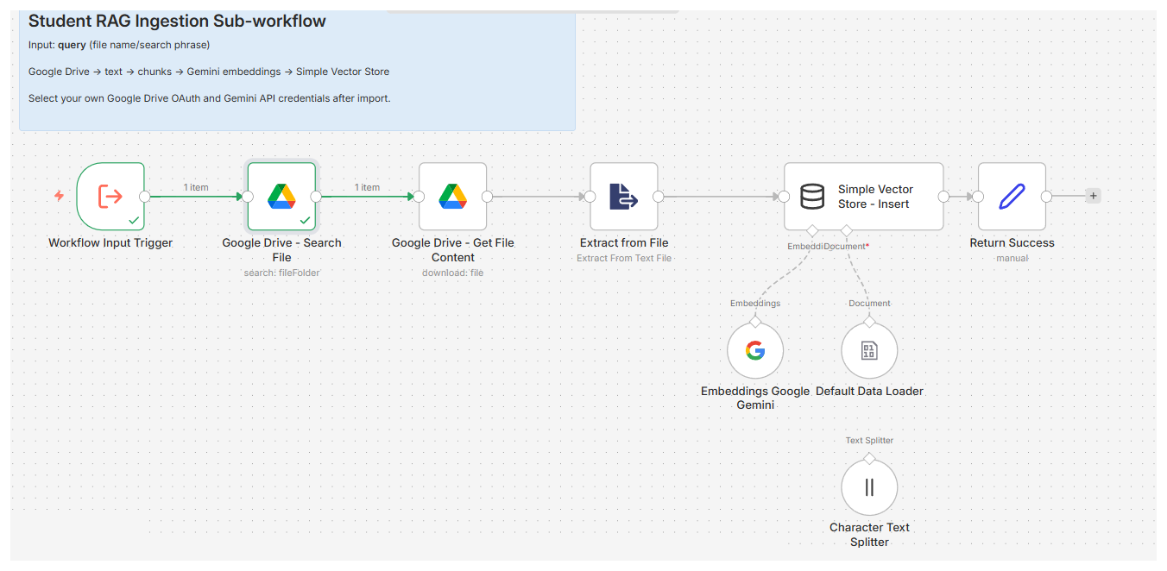
Figure 2. The supplied workflow on the n8n canvas. Today you work only on the two nodes on the left; the round nodes underneath (embeddings, data loader, text splitter) attach to the vector store as sub-nodes rather than sitting in the main line.

Node on the canvas | Its job | Used in
Workflow Input Trigger | Starts the workflow and accepts one input field named query. | Lesson 1
Google Drive – Search File | Finds a file in Drive by name and returns its name and ID. | Lesson 1
Google Drive – Get File Content | Downloads the file using the ID returned above. | Lesson 2
Extract from File | Converts the downloaded file into plain text. | Lesson 2
Character Text Splitter | Cuts the text into 1,000-character chunks with 200 overlap. | Lesson 2
Embeddings Google Gemini | Turns each chunk into a vector. | Lesson 2
Simple Vector Store – Insert | Stores the vectors under the key user_documents. | Lesson 2
Return Success | Reports back which file was indexed. | Lesson 2

2.8 Two setup words: API and OAuth
An API (Application Programming Interface) is an agreed way for two programs to talk to each other. Google Drive publishes an API: a documented set of requests such as “search for a file named X” or “download the file whose ID is Y”. n8n does not click around the Drive website — it sends these requests directly. Enabling the Google Drive API inside your Google Cloud project is what switches that door on.
OAuth is how you grant an application permission to act on your behalf without giving it your password.

KEY IDEA
The hotel key card. When you check into a hotel you are not handed the master key, and you certainly do not give the front desk your house keys. You receive a card that opens one room, works for a limited time, and can be cancelled the moment you lose it. OAuth is that card. n8n receives a token that reaches your Drive, expires, and can be revoked from your Google account at any time — and at no point does n8n ever see your Google password.

Three things you are about to create, and what each one is for:

Thing | What it is | Where it lives
Google Cloud project | A container that holds your enabled APIs and your credentials. Everything you create today must live in the same one. | Google Cloud
OAuth client (ID + secret) | The identity of the application that is asking for permission — in our case, your copy of n8n. | Google Cloud
Redirect URL | The address Google sends the browser back to after you approve. n8n generates this string; you copy it into Google unchanged. | n8n → Google Cloud

SECURITY RULE
A client secret is a password for your application. Never paste one into a chat, an assignment, a public repository or a classroom screenshot. If a secret is ever exposed, delete that OAuth client in Google Cloud and create a new one — it takes two minutes and costs nothing.

2.9 Where Lesson 1 stops, and why
You now know the whole pipeline, but you will build only its first link today.

LESSON SCOPE
Built today: Google Drive → OAuth → n8n → Search File → file name + file ID
Built later: Get Content → Extract Text → Split → Embeddings → Vector Store → Retrieval → AI Agent

The boundary is not arbitrary. Every later step depends on n8n being able to reach the file at all. If authentication is shaky, you will spend Lesson 2 debugging Lesson 1 while trying to learn embeddings at the same time. Finish this foundation cleanly and the rest of the module is far easier.

Part 3 · Before You Start
Five minutes of preparation prevents most of the problems students meet in this lab.

3.1 Prerequisites
✓ | You need | How to check
☐ | A Google account you can sign into | Open drive.google.com and confirm you are signed in. Note which account it is — you will need the same one later.
☐ | Access to n8n | Either an n8n Cloud workspace, or a local instance in your browser (commonly http://localhost:5678).
☐ | The two class files | University_AI_Course.txt and the workflow JSON, downloaded to your computer.
☐ | About 20 free minutes | The Google Cloud setup is a one-time cost. It is quick the second time.

3.2 The files you were given
File | What it is | What you do with it
University_AI_Course.txt | A short factual document about the AI training program. | Upload it to your Google Drive.
n8n_Student_RAG_Gemini_  Direct_Ingestion_  Subworkflow.json | A ready-made n8n workflow containing the full indexing pipeline. | Import it into n8n.

NOTE
The sample document was chosen because it is small enough to read in a minute and dense with checkable facts — student numbers, module names, a pass mark, a deadline. In later lessons you will ask questions about exactly these facts and be able to verify every answer. The full text is reproduced in Appendix B.

3.3 Ground rules for credentials
SECURITY RULE
1. Never share or display a Client Secret, an OAuth token or an API key. Not in class, not in an assignment, not in a screenshot.
2. Before taking a screenshot for homework, blur or crop anything that looks like a long random string.
3. Never commit credentials to GitHub. Automated scanners find exposed keys within minutes.
4. Each student uses their own Google Cloud project and their own OAuth client. Do not share one client across the class.
5. If you think a secret leaked, delete that OAuth client in Google Cloud immediately and create a new one.

Part 4 · The Lab, Step by Step
Work through the nine steps in order. Each one ends with a short check — do not move on until it passes, because every step depends on the one before it.

Step | What you do | Where | You are done when
1 | Upload the course file | Google Drive | The file is visible in My Drive
2 | Create or select a project | Google Cloud | The project name shows in the top bar
3 | Enable the Google Drive API | Google Cloud | The API page shows it as enabled
4 | Configure the consent screen | Google Cloud | Your own account is listed as a test user
5 | Create the OAuth client | n8n → Google Cloud | You hold a Client ID and Client Secret
6 | Connect the credential | n8n | n8n shows Connection successful
7 | Import the workflow | n8n | Eight nodes appear on the canvas
8 | Understand the input | n8n | You can explain field name vs value
9 | Search for the file | n8n | The node returns a name and an ID

Step 1 · Upload the course file to Google Drive
About 3 minutes
The knowledge source has to exist before anything can find it.
- Open drive.google.com and sign in. Note carefully which Google account this is — every later step must use the same one.
- Drag University_AI_Course.txt into My Drive, or use New → File upload.
- Leave the file name exactly as it is. Do not rename it, and do not let your browser turn it into University_AI_Course (1).txt.

CHECKPOINT
The file appears in My Drive with the exact name University_AI_Course.txt and opens when you double-click it.

TIP
Spelling matters more than you expect. In Step 9 you will search for this file by name, and Drive will not correct a typo for you. Copy the name from the file itself rather than typing it from memory.

Step 2 · Create or select your Google Cloud project
About 4 minutes
A Google Cloud project is a container. Your enabled APIs live in it, and so do your credentials. Almost every failure in this lab traces back to two things ending up in two different projects — so choose one project now and stay in it.
- Go to console.cloud.google.com and sign in with the same Google account as Step 1.
- Click the project selector in the blue bar at the top of the page.
- Either pick the project you already prepared, or click New project.
- Give it a name you will recognise — n8n Google Drive is a good choice — and click Create.
- Wait for the notification, then make sure the new project is the one shown in the top bar.
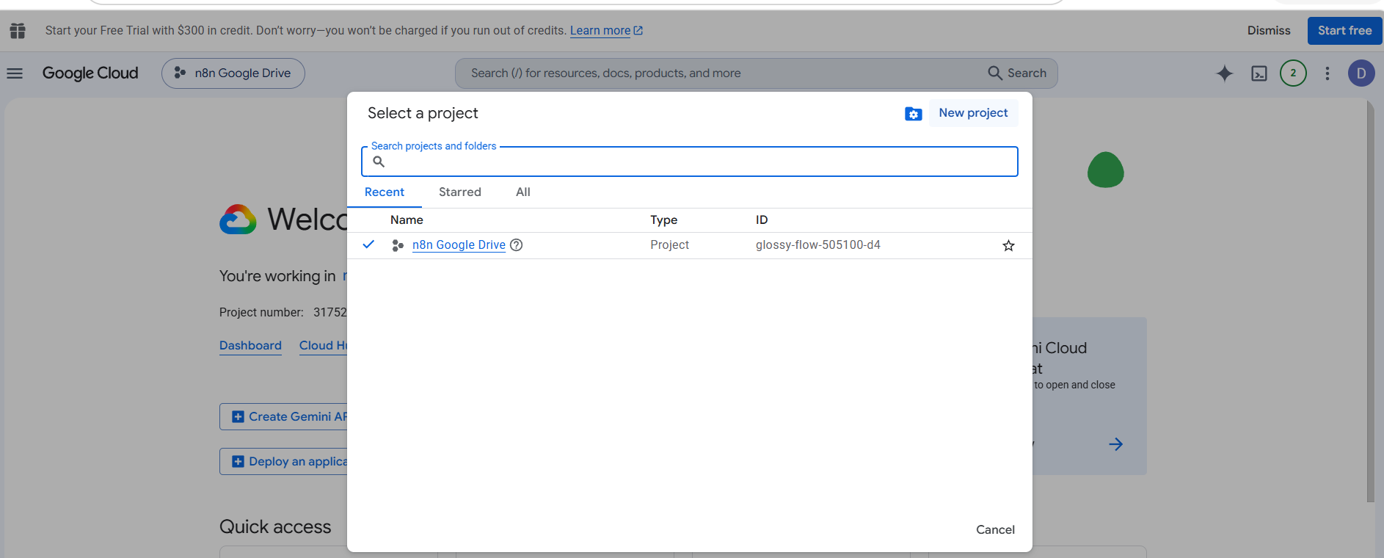
Figure 3. The project selector. The tick shows which project is currently active — this is the name that must appear in the top bar for the rest of the lab.
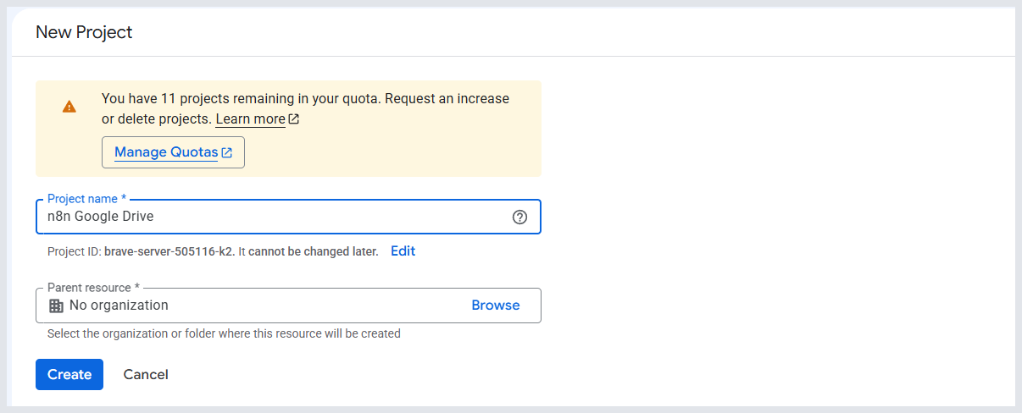
Figure 4. Creating a new project. The project name is for humans; the project ID underneath is what Google uses internally and what will appear in error messages later.
NOTE
Write your project name here: ________________________________ and its ID: ________________________________
You will need the ID to read error messages in Part 5, where Google refers to your project by ID rather than by name.

CHECKPOINT
The blue bar at the top of Google Cloud Console shows your chosen project name.

Step 3 · Enable the Google Drive API
About 4 minutes
By default a new project can talk to nothing. Enabling an API is how you open one specific door — in our case, the door to Google Drive.
- Confirm your project is still selected in the top bar.
- Open the navigation menu (☰) and choose APIs & Services → Library.
- Type Google Drive API into the search box.
- From the results, open the card titled exactly Google Drive API — not Google Drive Activity API, and not Drive Labels API.
- Click Enable and wait for the page to finish loading.
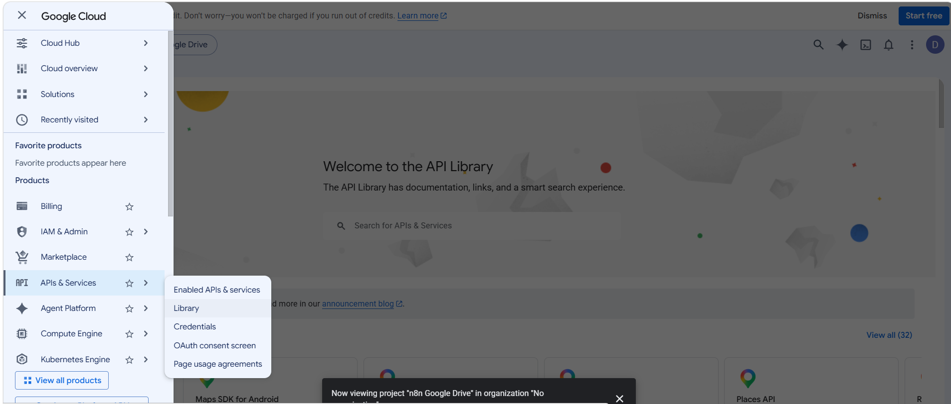
Figure 5. Reaching the API Library from the navigation menu: APIs & Services → Library.
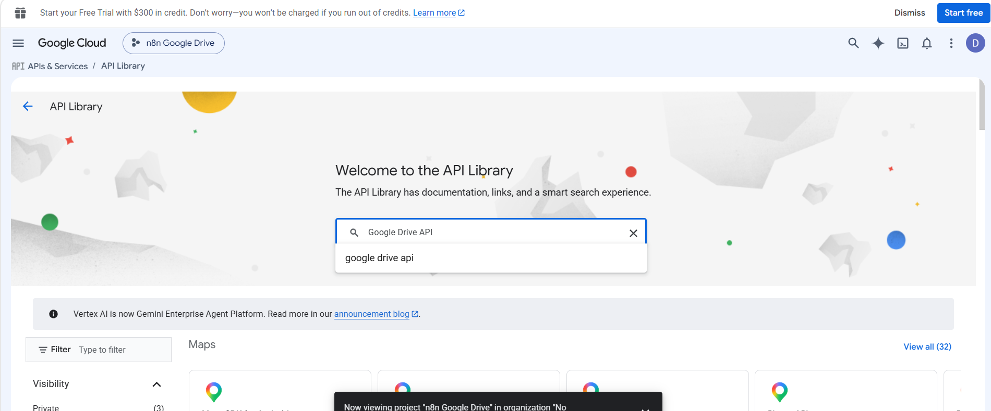
Figure 6. Searching the library. Note the project name in the top bar — it should be yours.
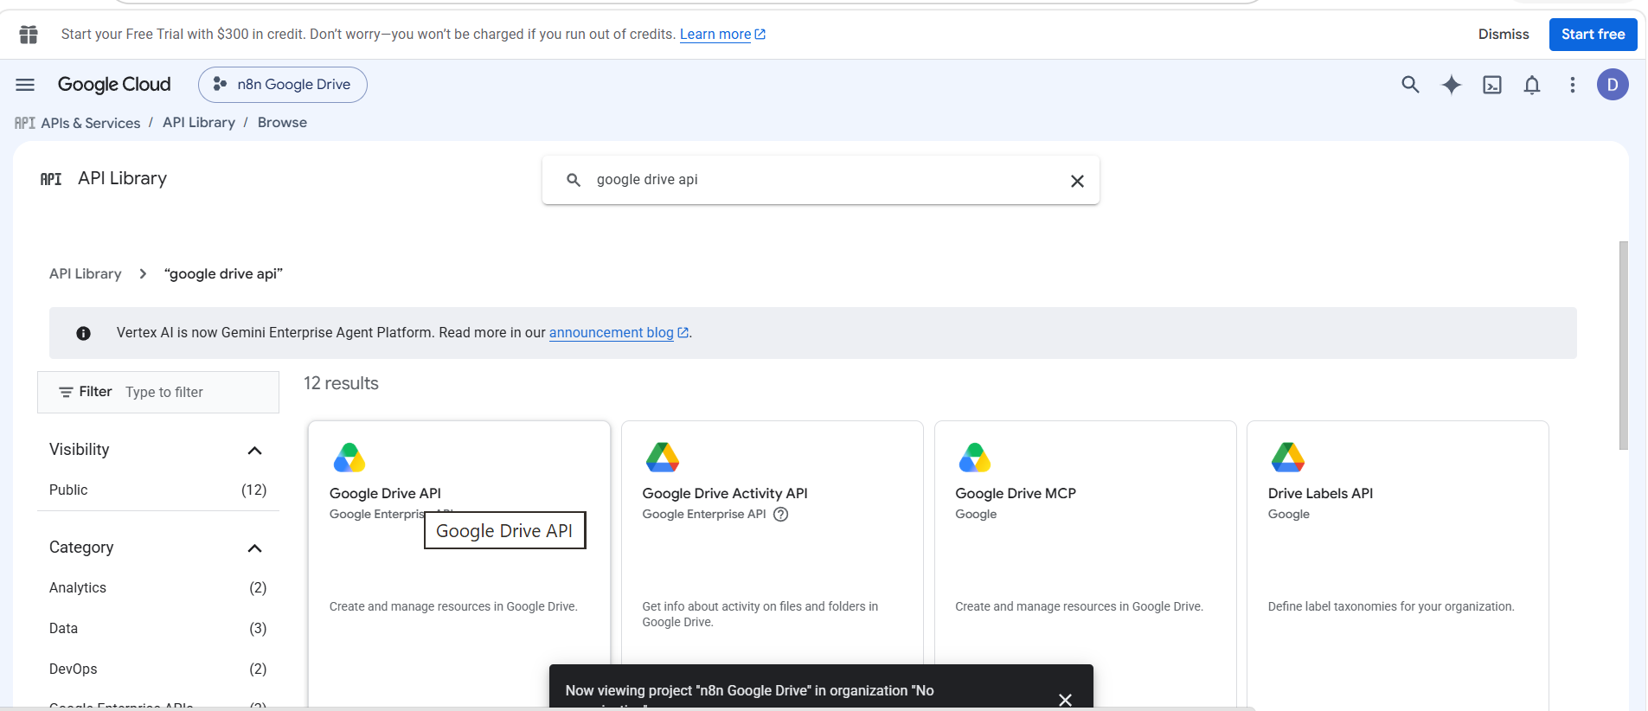
Figure 7. Choose the first card, Google Drive API. The similarly named APIs beside it do something different and will not fix a permission error.
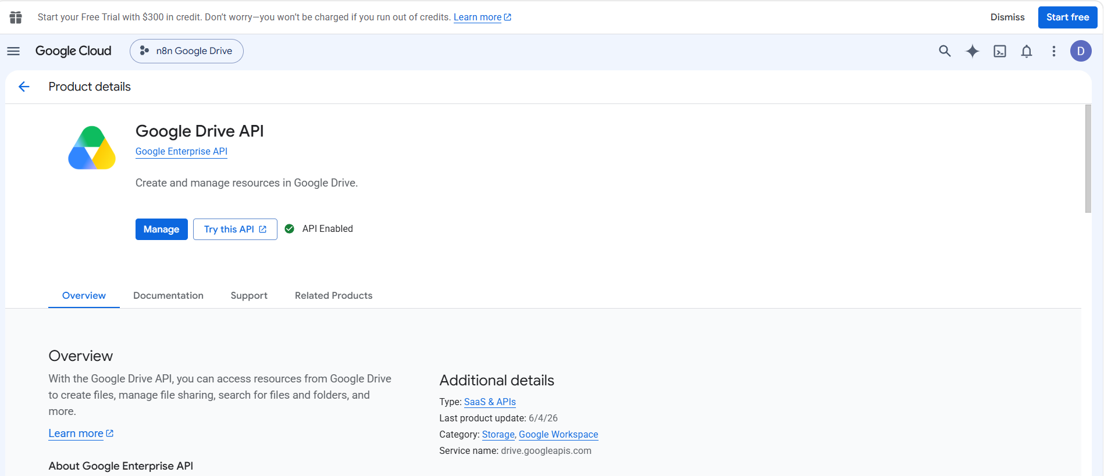
Figure 8. What a correctly enabled API looks like: the product page shows a green API Enabled badge and a Manage button instead of Enable.
COMMON ERROR
This is the most common failure in the whole lab. If you enable the API while a different project is selected, n8n will later report that the Drive API “has not been used in project … or it is disabled”, and nothing you change in n8n will help. Check the top bar before you click Enable.

CHECKPOINT
The Google Drive API page shows API Enabled with a Manage button, and the project name in the top bar is yours.

Step 4 · Configure the OAuth consent screen
About 8 minutes
The consent screen is what you see when Google asks “Do you want to give this application access to your Drive?” Google requires it to be configured before any OAuth client will work. In the current Google Cloud console this lives under Google Auth Platform.

4a · Start the configuration
- Open the navigation menu (☰) and choose Google Auth Platform, or type it into the search bar at the top of the console.
- If you have never configured it for this project, the page reads Google Auth Platform not configured yet.
- Click Get started.
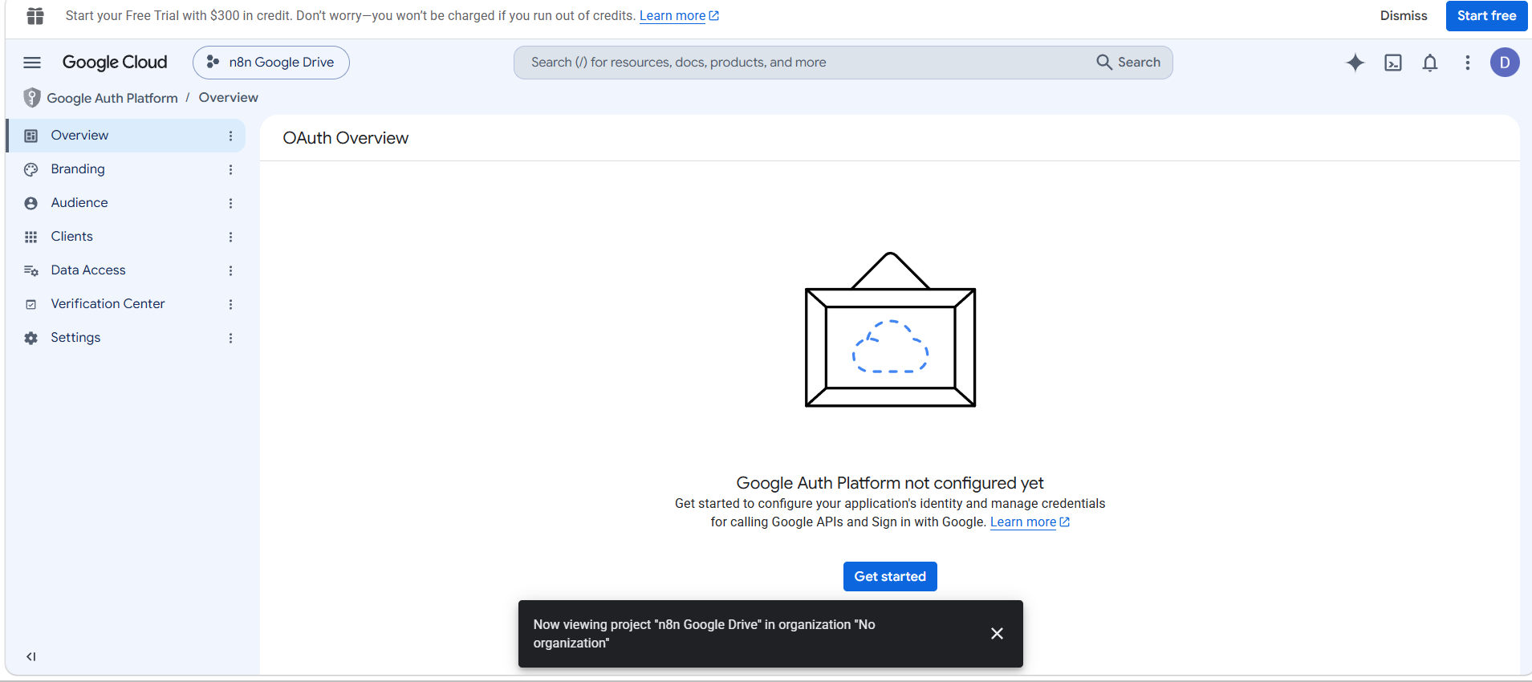
Figure 9. A fresh project. Get started opens a short four-step form — this is the modern replacement for the old OAuth consent screen page.

4b · Fill in the four steps
- App Information — enter an App name such as n8n Google Drive, and choose your own address as the User support email. Click Next.
- Audience — choose External. A personal Google account has no other option, and it is the correct choice for a classroom project. Click Next.
- Contact Information — enter your own email address again. Click Next.
- Finish — agree to the user data policy, then click Create.
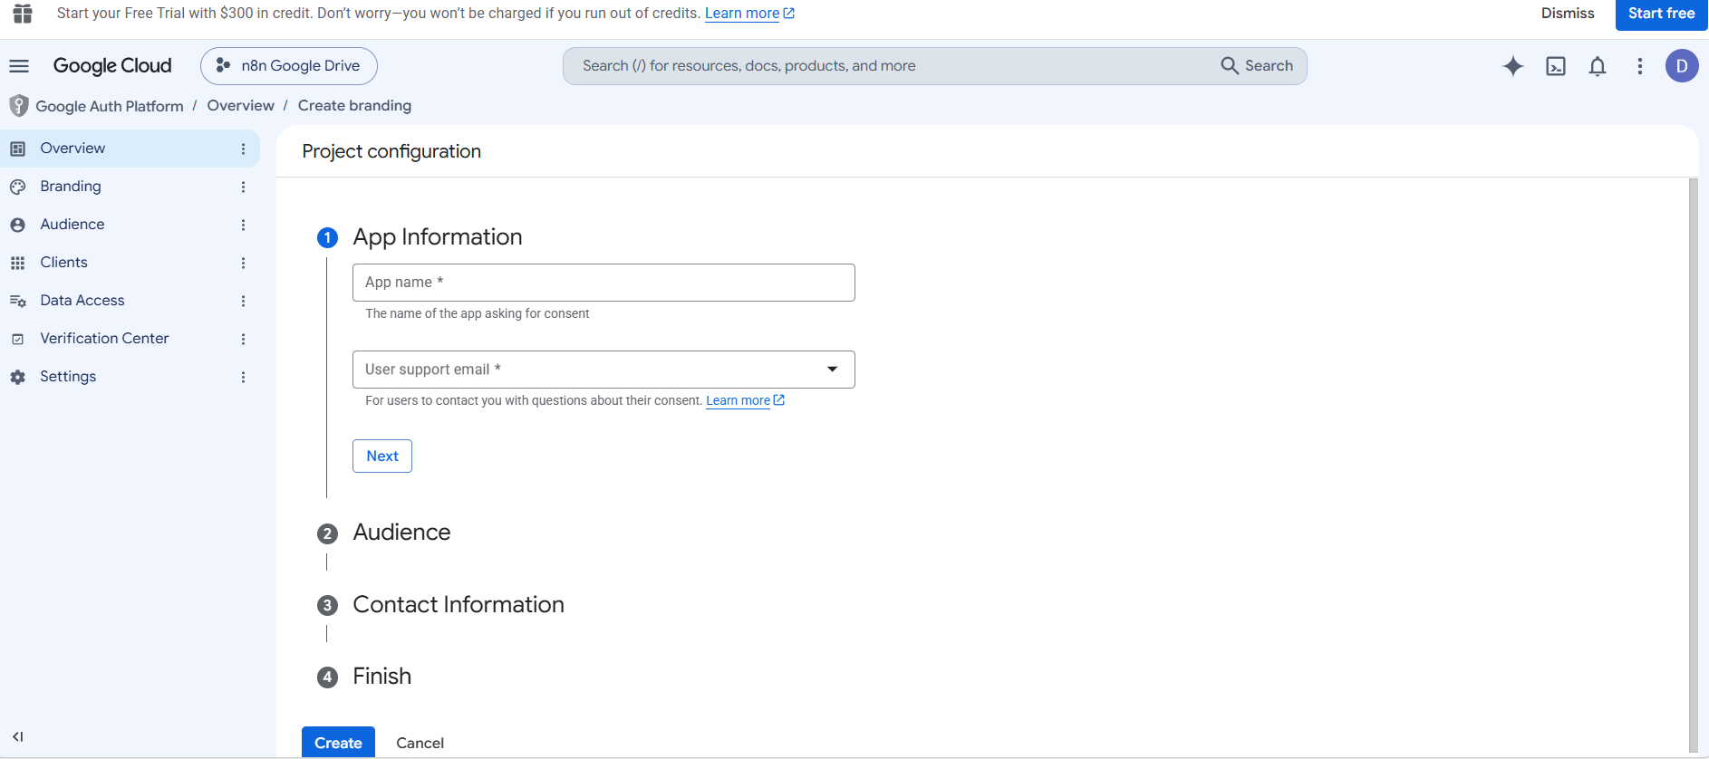
Figure 10. The four-step form. Each section opens as you complete the one above it.
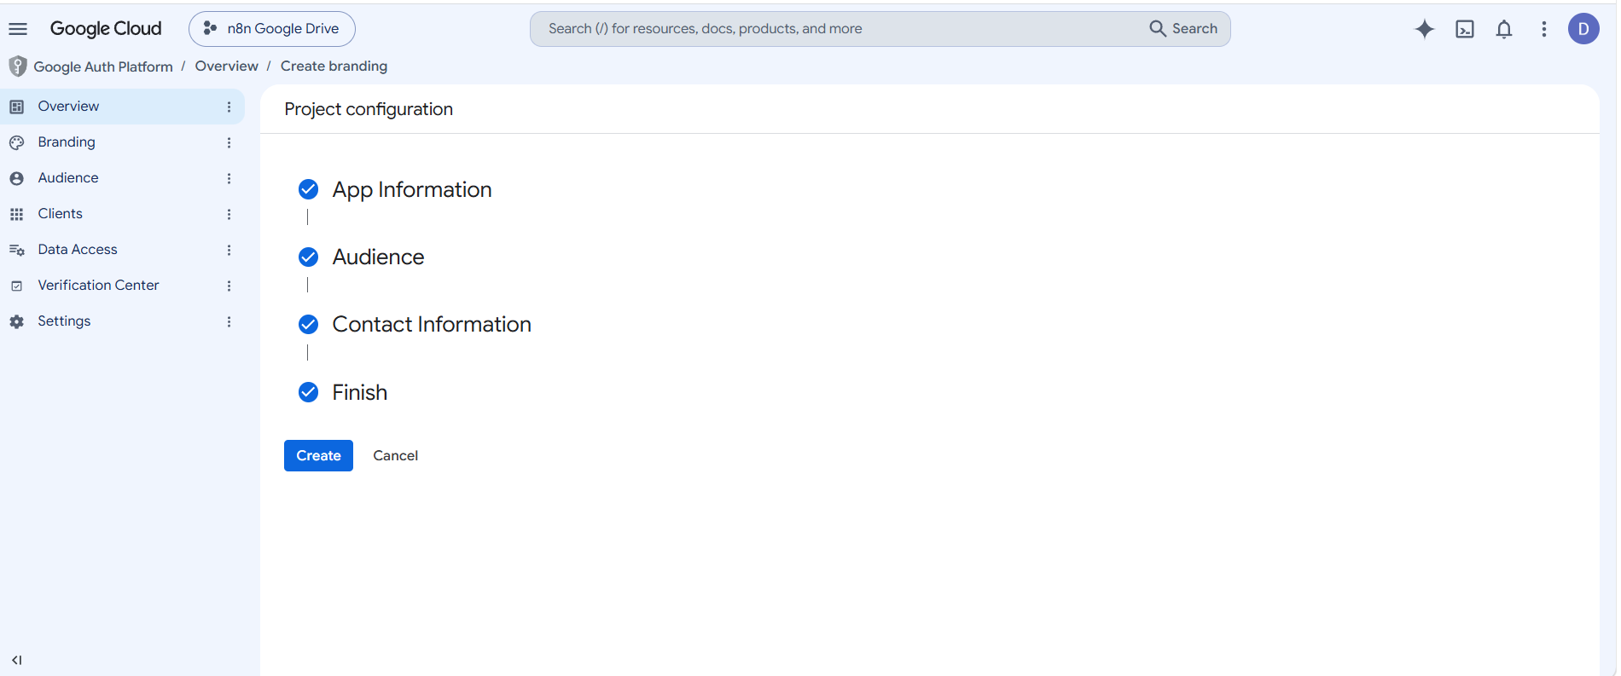
Figure 11. All four steps ticked. Click Create to write the configuration.

4c · Add yourself as a test user
This is a separate page, and skipping it is the single most common mistake in this lab.
- In the left menu of Google Auth Platform, open Audience.
- Scroll to Test users and click + Add users.
- Type the exact Google account you will use to connect n8n — the same one holding the file from Step 1 — and save.
- Confirm the address now appears in the Test users table.
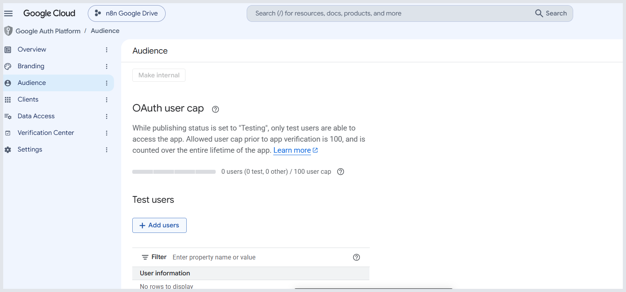
Figure 12. The Audience page. While publishing status is Testing, only the accounts listed here can sign in — the page says so directly under “OAuth user cap”.
COMMON ERROR
Why Test users matters. While an app is in Testing mode, Google allows only the accounts on that list to sign in. Every other account is refused with “Access blocked: … has not completed the Google verification process.”
If you are going to make one mistake in this lab, it will be this one. Add yourself as a test user now, before you go anywhere near n8n.

NOTE
You do not need to publish the app, and you do not need Google verification. Verification is for applications used by the public. A classroom project stays in Testing mode indefinitely, with a cap of 100 test users.

CHECKPOINT
Your own Google address is visible in the Test users table on the Audience page.

Step 5 · Create the OAuth client and copy the redirect URL
About 7 minutes
Read this before you start: the order is unusual. You need a redirect URL from n8n before you can finish the form in Google, so open n8n first.

5a · Get the redirect URL out of n8n
- In n8n, open Credentials and click Add credential.
- Search for and select Google Drive OAuth2 API.
- Near the top of the form n8n shows an OAuth Redirect URL. Copy it with the copy button — do not retype it.
- Leave this n8n tab open. You will come back to it in a moment.
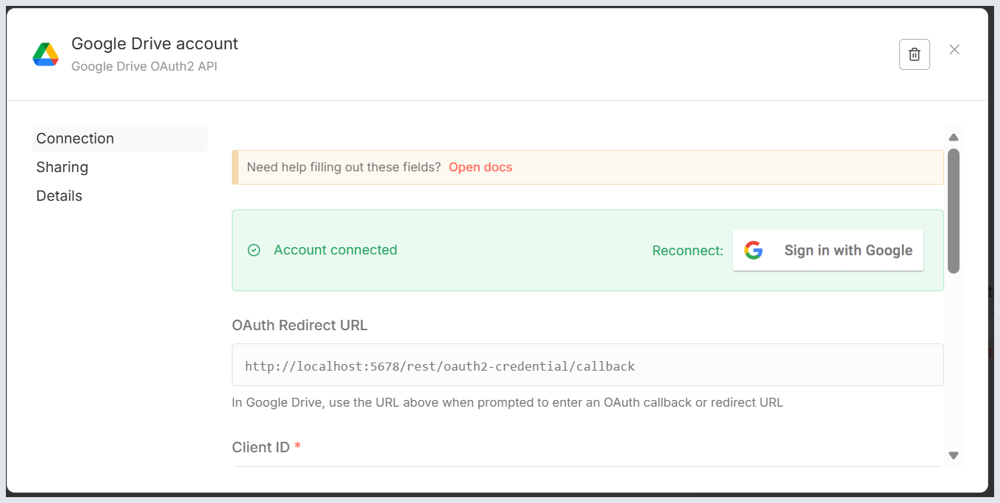
Figure 13. The n8n Google Drive credential. The OAuth Redirect URL is the string Google needs — copy it with the button beside it rather than retyping it. (This screenshot was taken after connecting, which is why the bar above is already green.)
Typical redirect URLs

local install
http://localhost:5678/rest/oauth2-credential/callback

n8n Cloud
https://<workspace>.app.n8n.cloud/rest/oauth2-credential/callback

5b · Create the client in Google Cloud
- Back in Google Cloud, open Google Auth Platform → Clients (older consoles: APIs & Services → Credentials).
- Click Create OAuth client.
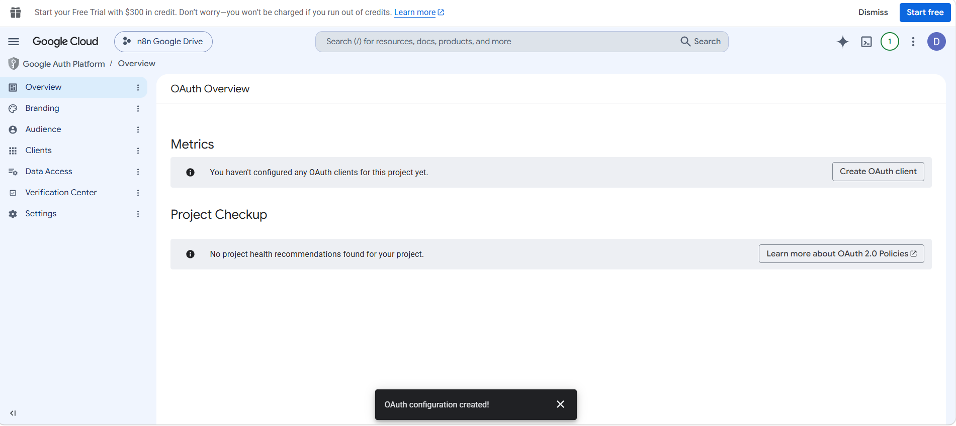
Figure 14. Straight after Step 4 the Overview page says you have no OAuth clients yet, and offers the Create OAuth client button.
- Set Application type to Web application. This is correct even for a local n8n, because n8n receives Google's response in a browser.
- Give the client a clear name, such as n8n Google Drive Client.
- Leave Authorised JavaScript origins completely empty — n8n does not use it.
- Scroll to Authorised redirect URIs, click + Add URI, and paste the URL you copied from n8n. Paste it — do not type it.
- Click Create. Google shows your Client ID and Client Secret. Copy both now.
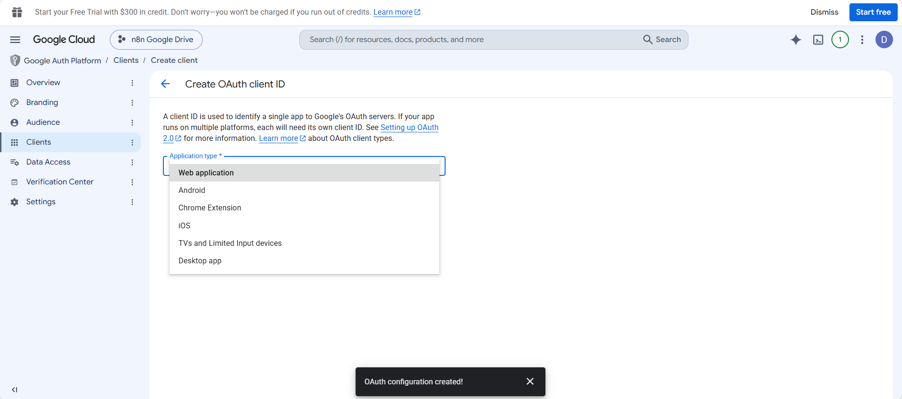
Figure 15. Application type. Web application is the right choice; the other options are for mobile apps, browser extensions and TVs.
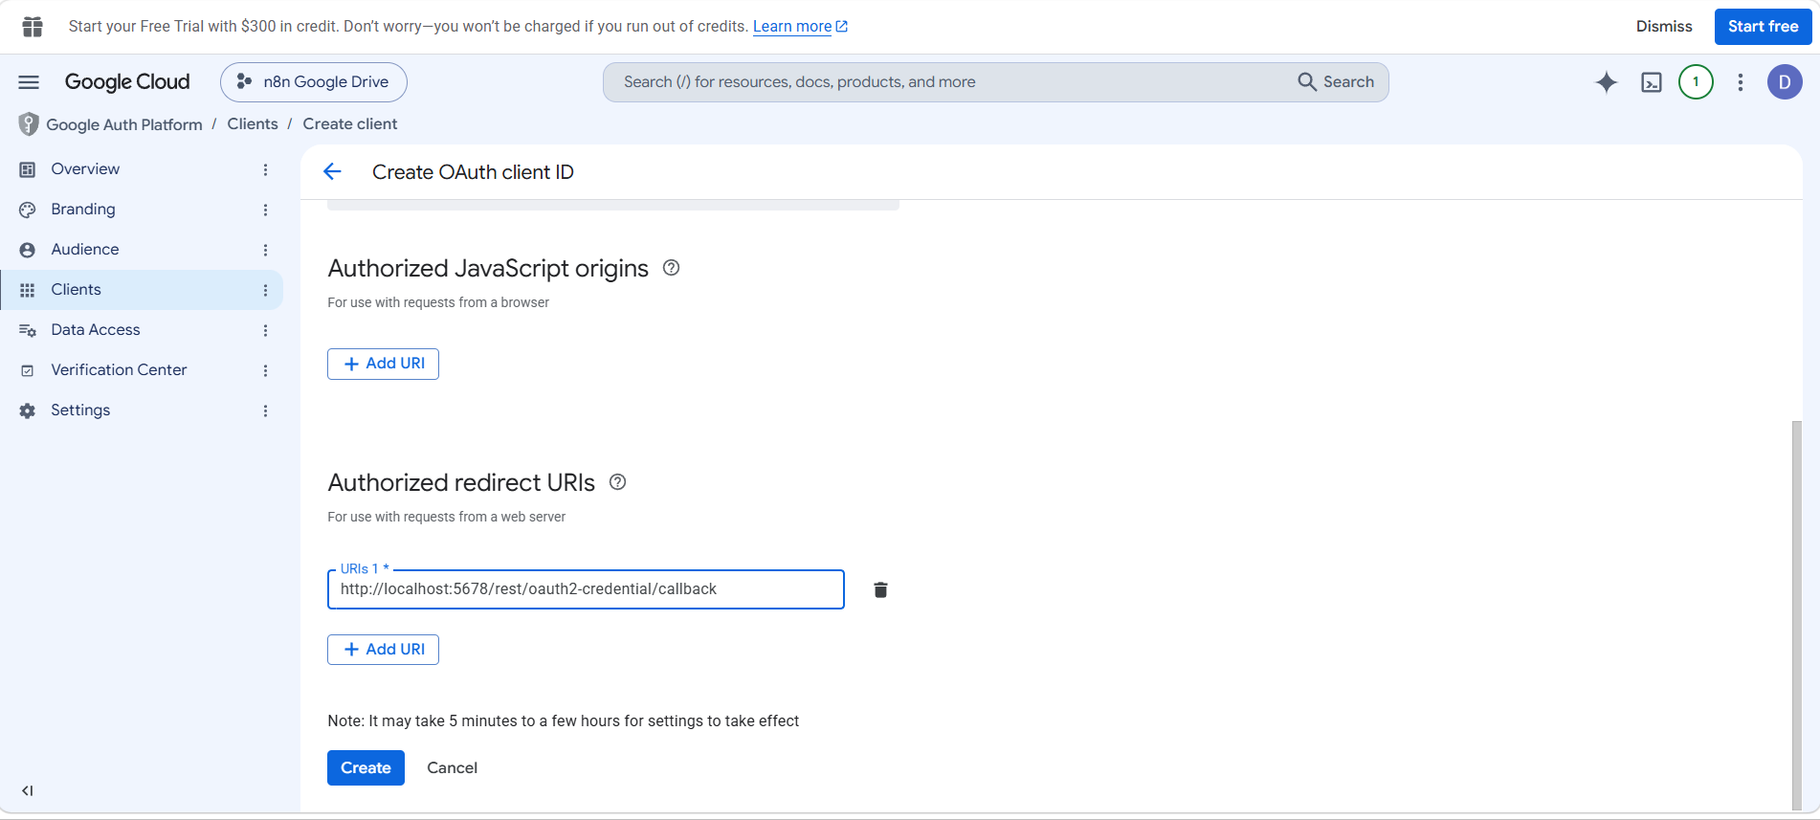
Figure 16. The redirect URI pasted in. Note Google's own warning underneath: changes here can take 5 minutes to a few hours to take effect.
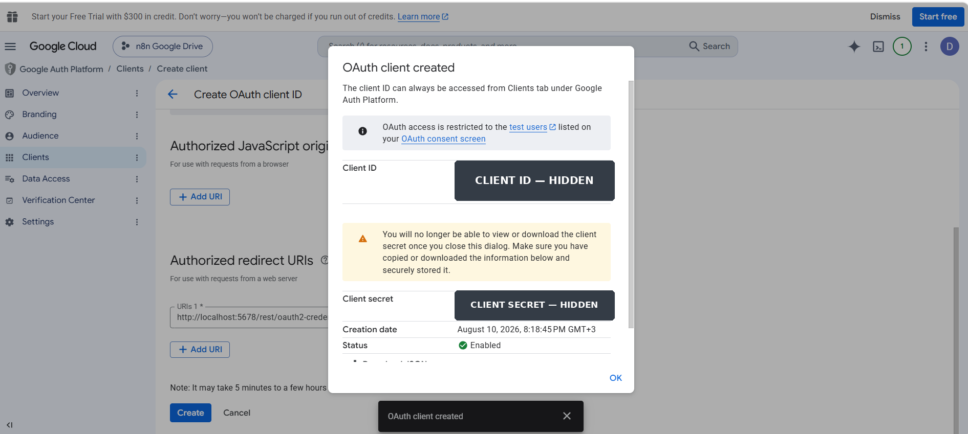
Figure 17. The client is created. Copy both values into n8n now — Google will not show the secret again. The values are masked here because a Client Secret must never appear in teaching material.
COMMON ERROR
redirect_uri_mismatch. Google compares the redirect URI character by character. These are all different URIs, and any mismatch fails:
http://localhost:5678/… vs https://localhost:5678/…
…/callback vs …/callback/ (a trailing slash counts)
localhost:5678 vs localhost:5679 (the port counts)

NOTE
Be patient for a minute. Google's own note on this page says settings can take between five minutes and a few hours to take effect. In practice it is usually instant, but if you get a redirect_uri_mismatch immediately after creating the client, wait two minutes and retry before assuming you mistyped something.

SECURITY RULE
The Client Secret is a password. Copy it straight into n8n, and do not paste it anywhere else — not into a document, a chat, a slide, or a screenshot you are about to submit. If one is ever exposed, delete that OAuth client under Clients and create a new one; it takes two minutes and costs nothing.

CHECKPOINT
You have a Client ID ending in .apps.googleusercontent.com and a Client Secret, and your redirect URI is listed on the client.

Step 6 · Connect the credential in n8n
About 4 minutes
This is the moment OAuth actually happens: n8n asks Google for permission, you approve it, and Google hands n8n a token.
- Return to the n8n credential tab from Step 5a.
- Paste the Client ID and the Client Secret into their fields.
- Click Sign in with Google. A Google window opens.
- Choose the Google account from Step 1 — the same one you added as a test user.
- If a warning about an unverified app appears, that is expected for a Testing app. Continue.
- Approve the requested Google Drive access.
- Give the credential a clear name, such as Google Drive – my account, and save it.
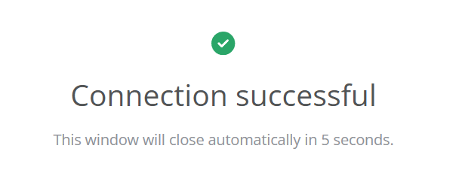
Figure 18. First sign: the Google pop-up reports Connection successful and closes itself after a few seconds.
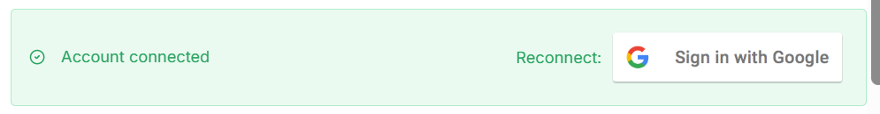
Figure 19. Second sign, and the one that really matters: back in n8n the credential shows a green Account connected bar. If you ever need to re-authorise, Reconnect is on the same line.
CHECKPOINT
n8n shows Connection successful, the pop-up closes, and the credential displays a green Account connected bar.

WATCH OUT
If it did not work, stop here. Do not continue to Step 7 — every remaining step depends on this connection. Match your symptom against these:

WHAT EACH SYMPTOM MEANS
Access blocked / 403 → you are not on the Test users list, or you signed in with a different account. Return to Step 4c.
redirect_uri_mismatch → re-copy the URL from n8n into the OAuth client. Return to Step 5b.
invalid_client → the Client ID or Secret has a stray space, or came from a different client. Re-copy both.
Nothing happens at all → your browser blocked the pop-up. Allow pop-ups for n8n and try again.

Step 7 · Import the workflow into n8n
About 3 minutes
Rather than building eight nodes by hand, you import the finished workflow and study it.
- In n8n, create a new blank workflow.
- Open the ⋯ menu at the top right of the canvas.
- Choose Import from File….
- Select n8n_Student_RAG_Gemini_Direct_Ingestion_Subworkflow.json.
- Save the workflow and give it a name you will find again.
- Open Google Drive – Search File and, in Credential to connect with, select the credential you created in Step 6.

WATCH OUT
An imported workflow never brings credentials with it. That is a safety feature, not a bug — a shared workflow file would otherwise leak the author's access to their own Drive. Any Google node you use must be pointed at your credential after import.

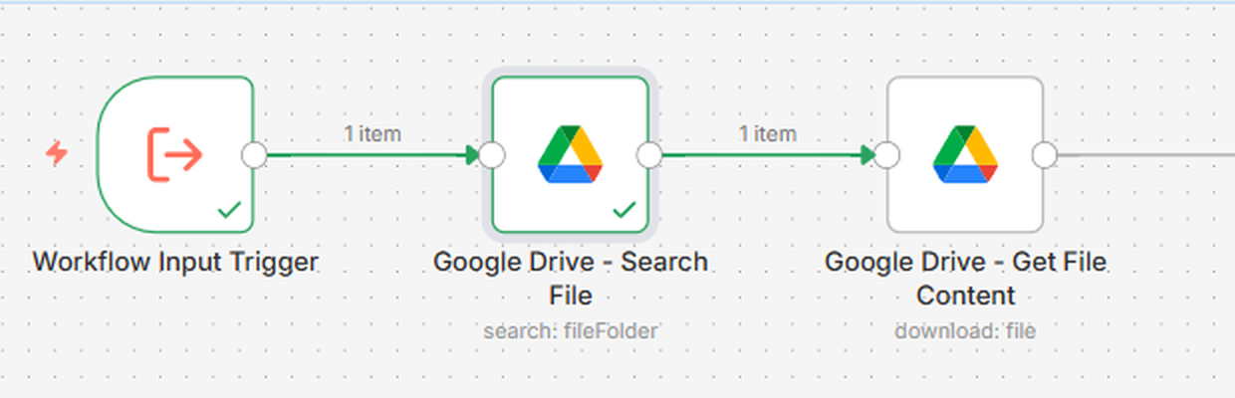
Figure 20. After import, these are the only two nodes Lesson 1 uses. The third node onwards belongs to Lesson 2.
CHECKPOINT
Eight nodes are on the canvas, the workflow is saved, and the Search File node shows your own credential.

Step 8 · Understand the input: field name against value
About 4 minutes
Open the Workflow Input Trigger node. It defines exactly one input field:

Field name : query
Type : String

This is where students most often go wrong, so it is worth being precise. The field is a labelled slot; the file name is what you put into the slot.

Correct | Incorrect
Field name: query  Value passed in: University_AI_Course.txt | Field name: University_AI_Course.txt  Value passed in: — nothing sensible left to pass
The workflow can search for any file. Change the value and it searches for something else. | The workflow can only ever look for one hard-coded thing, and the expressions inside the node break.

KEY IDEA
The envelope. The field name is the label printed on the envelope — “Search term”. The file name is the letter you put inside. You do not reprint the envelope every time you send a different letter.

Inside Google Drive – Search File, the Search Query is written as the expression {{ $json.query }}. That expression means “whatever value arrived in the field called query”. Rename the field and the expression points at nothing, which is why the mistake above breaks the node rather than merely being untidy.

CHECKPOINT
You can explain, out loud, why the field is called query and not University_AI_Course.txt.

Step 9 · Search for the real file and read the result
About 6 minutes
Open Google Drive – Search File and set the parameters exactly as follows.

Parameter | Value | Why
Credential | Your Google Drive credential from Step 6 | Proves who is asking
Resource | File/Folder | We are looking for a file, not a permission or a drive
Operation | Search | Find by name rather than fetch by a known ID
Search Method | Search File/Folder Name | Matches against the file's name
Search Query | University_AI_Course.txt | The classroom test file. In the finished workflow this comes from the query field.
Return All | Off | One result is enough for this test
Limit | 1 | Returns only the closest match

Now click Execute step (or Test step, depending on your n8n version). The node runs on its own, which is exactly what you want while testing.
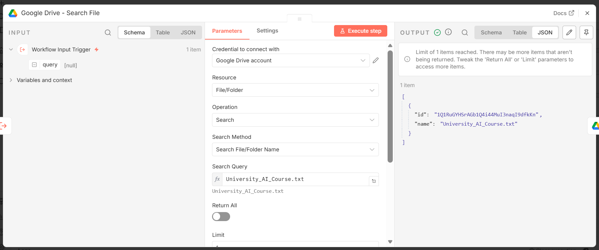
Figure 21. The configured node. Parameters are in the middle panel; the returned data is on the right.

Reading the output
[
{
"id": "1Q1RuGYHSrAGb1Q4i44MuI3naqI9dfkKn",
"name": "University_AI_Course.txt"
}
]

Field | What it is | Why it matters
name | The file's display name in Drive. | Confirms you found the file you meant, and not a similarly named one.
id | The file's permanent, unique address inside Google Drive. | Lesson 2 downloads the file by ID, never by name. The ID does not change when the file is renamed or moved.

SUCCESS CRITERION
Lesson 1 is complete. A real name and a real ID came back, which proves three separate things at once: the Google Drive API is enabled in your project, your OAuth authorisation is valid, and n8n can securely see a real file in your Drive. That is the foundation the entire RAG pipeline stands on.

NOTE
Optional, if you have time. Change the Search Query to a file that does not exist and run the node again. It returns zero items rather than an error — worth seeing now, because in Lesson 2 an empty result is what you will get when a file name is wrong, and it can be mistaken for a broken workflow.

Part 5 · Troubleshooting Guide
Almost every problem in this lab is one of nine things. Find your symptom in the left column.

# | What you see | Why it happens | How to fix it
1 | “Access blocked: … has not completed the Google verification process”  (403) | Your OAuth app is in Testing mode and the account you signed in with is not on the test-user list. | Google Cloud → OAuth consent screen → Test users → add that exact address. Then sign in again.
2 | “Google Drive API has not been used in project 3175… or it is disabled” | The Drive API is enabled in a different project from the one your OAuth client belongs to — or in no project at all. | Read the project number in the message. Open that project, enable the Drive API, wait 2–5 minutes, retry.
3 | redirect_uri_mismatch | The redirect URI registered in Google is not byte-for-byte identical to the one n8n uses. | Copy the URL from n8n again and paste it into the OAuth client. Check http vs https, the port, and any trailing slash.
4 | invalid_client / “The OAuth client was not found” | The Client ID or Secret was copied with a leading space, truncated, or taken from a different client. | Re-copy both values from Google Cloud → Credentials and paste them again.
5 | The node runs but returns 0 items | The file name does not match, the file is in a different Google account, or it is in the Trash. | Compare the name character by character. Confirm the authorised account is the one holding the file. Check the Trash.
6 | The wrong file comes back | Drive matches partial names, and Limit 1 returns whichever match ranks first. | Search using the complete file name. If several files share it, rename one for the test.
7 | The Google window opens and closes with nothing | A pop-up blocker closed the OAuth window before it could return the token. | Allow pop-ups for the n8n address, then click Sign in with Google again.
8 | The credential says connected, but the node fails with 401 | The token was revoked, expired, or you later signed into a different Google account. | Open the credential in n8n and reconnect it.
9 | It works on my laptop but not for my classmate | Each n8n installation has its own redirect URL, so one OAuth client cannot serve everybody. | Every student creates their own OAuth client with their own redirect URL.

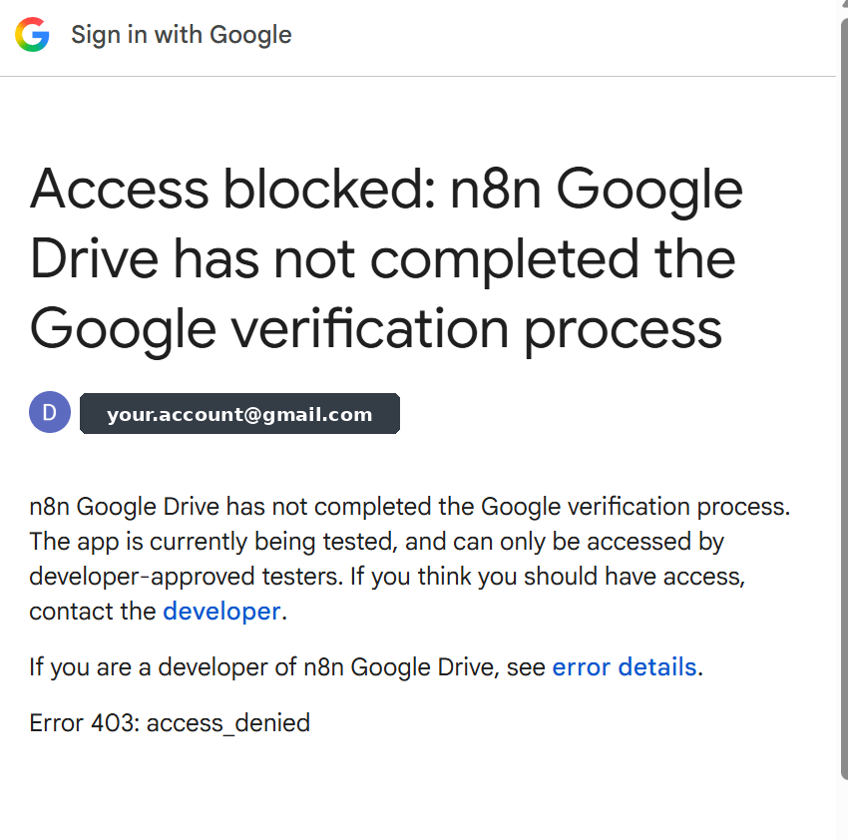
Figure 22. Problem 1 as students actually see it. The wording never mentions test users, which is why it sends people looking in the wrong place. Error 403: access_denied means exactly one thing — the account signing in is not on the Test users list.

KEY IDEA
The one question that solves most of these. Are the enabled Drive API, the OAuth client, and the n8n credential all in the same Google Cloud project, authorised with the same Google account? Check that before changing anything else — it resolves items 1, 2, 4 and 5.

How to read a Google error message
Google's errors are wordy but they almost always name the project causing the problem. Learning to spot it is a genuinely useful skill:
Google Drive API has not been used in project 317524... before or it is
^^^^^^^^^
is this YOUR project?
disabled. Enable it by visiting https://console.developers.google.com/
apis/api/drive.googleapis.com/overview?project=317524... then retry.

If that number does not match the project you have been working in, you have found the problem: you enabled the API in one project and created credentials in another. Opening the link in the message takes you straight to the correct page.

Part 6 · Lesson Checkpoint
Complete this before you leave the session. The evidence column is what your instructor will ask to see.

✓ | I can… | Evidence
☐ | Explain what RAG is and why an LLM needs it | Say it out loud in two sentences
☐ | Define document, chunk, embedding, vector store, semantic search | Define each without looking at the manual
☐ | Explain why OAuth is used instead of a password | The hotel key card, in your own words
☐ | Name the Google Cloud project my credential belongs to | Read it from the top bar
☐ | Show that the Google Drive API is enabled in that project | The API page shows Manage, not Enable
☐ | Show a working Google Drive credential in n8n | The credential is green / connected
☐ | Import a workflow from a JSON file | Eight nodes on the canvas
☐ | Explain the difference between field name and value | query is the field; the file name is the value
☐ | Return University_AI_Course.txt and its file ID | The node output shows name and id
☐ | Diagnose a 403 and a “Drive API disabled” error | Say the first thing you would check

TIP
Teach it to somebody else. Turn to the person next to you and explain, in under a minute, what happened when you clicked “Sign in with Google” — what n8n asked for, what Google checked, and what n8n received. If you can do that fluently, you have understood OAuth better than most people who use it daily.

Part 7 · Quick Quiz
Ten questions. Answer them from memory first, then check yourself against the answer key on the next page.

- What does RAG stand for, and what happens in each of the three parts?
- Why can a standard language model not answer a question about a file stored in your Google Drive? Give the reason, not just “it doesn't know”.
- What is a chunk, and give two reasons why documents are chunked rather than used whole.
- Define an embedding in one sentence, without using the word “embedding”.
- A student asks “What score do I need to pass?” The document says “Students must achieve at least 70% to successfully complete the program.” Which finds it — keyword search or semantic search — and why?
- What is the difference between an API and OAuth? One sentence each.
- In the Workflow Input Trigger, what is the field name and what is the value? Why does swapping them break the workflow?
- The Google Drive – Search File node returns two pieces of data. Name them and say what each is used for later.
- n8n reports: “Google Drive API has not been used in project 3175… or it is disabled.” What is the first thing you check?
- Why does Lesson 1 stop after the Search File node instead of continuing to embeddings?

NOTE
Questions 3, 5 and 7 are the ones students most often get half-right. If you can answer those three confidently, you are ready for Lesson 2.

Answer key
Model answers. Yours does not need to match word for word — it needs to contain the same ideas.

# | Model answer
1 | Retrieval-Augmented Generation. Retrieval: search a knowledge source for passages related to the question. Augmented: add those passages to the prompt. Generation: the model writes the answer using them.
2 | Because the file was never part of the model's training data. Everything the model knows came from that data, and your private Drive was not in it — so the fact simply is not there to recall.
3 | A chunk is a small slice of a document, roughly a paragraph, that can be retrieved on its own. Two reasons: a model can only read a limited amount of text at once, and retrieving a whole document buries the relevant sentence in irrelevant text, which makes the answer worse.
4 | A list of numbers that describes the meaning of a piece of text, positioned so that text with similar meaning gets similar numbers.
5 | Semantic search. The words “score” and “pass” never appear in the sentence, so a keyword search finds nothing. Semantic search compares meaning, and “what score do I need to pass” means almost the same thing as “must achieve at least 70% to successfully complete”.
6 | API: an agreed set of requests one program can send to another — how n8n asks Google Drive to search or download. OAuth: a way to grant an application permission to act on your behalf without giving it your password, using a token you can revoke.
7 | The field name is query; the value is the file name, for example University_AI_Course.txt. Swapping them breaks the workflow because the Search File node reads the expression {{ $json.query }} — rename the field and that expression refers to nothing.
8 | name confirms you found the intended file; id is the file's permanent unique address, which Lesson 2 uses to download the content. Downloads use the ID, not the name, because the ID does not change if the file is renamed or moved.
9 | Whether the project number in the message is the project you have been working in. If the Drive API was enabled in a different project from the one holding your OAuth client, that is the cause.
10 | Because everything that follows depends on n8n being able to reach the file at all. If authentication is not solid, later errors are impossible to diagnose — you would be debugging Lesson 1 while trying to learn embeddings.

Part 8 · Homework
Two required tasks and one optional task. Together they are worth 10 marks.

Task A — Repeat the lab with your own document (4 marks)
- Choose or write a short document of your own — lecture notes, a club's rules, a personal reading list. Any plain text or Google Doc will do.
- Upload it to the same Google Drive account you used in class.
- In n8n, change the Search Query in the Search File node to your document's name.
- Run the node and capture a screenshot of the output panel showing the returned name and id.

SECURITY RULE
Before submitting your screenshot, crop or blur anything that could be a credential. The output panel is safe; the credential panel is not.

Task B — Short written answer (4 marks)
In 150–200 words, describe a real problem at your own university or workplace that a RAG system would solve. Your answer must cover all four points:
- The documents that would form the knowledge source, and roughly how many there are.
- Two example questions a real person would ask the system.
- Why RAG suits this problem better than retraining a model.
- One thing that could go wrong — out-of-date documents, private information, ambiguous wording — and how you would reduce the risk.

Task C — Optional, for bonus credit (2 marks)
- Open the workflow JSON in a plain text editor.
- Find the Character Text Splitter node and read the values of chunkSize and chunkOverlap.
- In three or four sentences, explain what would change if chunk size were 100 characters instead of 1,000, and what would change if it were 5,000. Comment on retrieval precision and on the amount of context sent to the model.

Part 9 · Glossary
Every term used in this lesson, in alphabetical order.

Term | Meaning
API | Application Programming Interface. An agreed set of requests one program can send to another. n8n reaches Google Drive through the Drive API.
Chunk | A small slice of a document, roughly a paragraph, that can be retrieved on its own. Our workflow uses 1,000 characters with 200 of overlap.
Chunk overlap | Text repeated between the end of one chunk and the start of the next, so that a sentence falling on a boundary is not lost.
Client ID | The public identifier of an OAuth application. Safe to show.
Client Secret | The private password of an OAuth application. Never show it, never commit it.
Consent screen | The Google page that asks whether you agree to give an application access to your data.
Context | The text placed in front of a model together with the question, so it can answer from that text.
Credential (n8n) | A saved set of authentication details that nodes reuse, so secrets are stored once rather than in every node.
Document | The original source file, before any processing.
Embedding | A list of numbers representing the meaning of a piece of text. Similar meanings produce numbers that lie close together.
File ID | A file's permanent unique address in Google Drive. It does not change when the file is renamed or moved.
Generative AI | Systems that produce new content — text, images, audio, code — rather than only classifying or predicting.
Google Cloud project | A container holding enabled APIs and credentials. Everything in this lesson must live in one project.
Hallucination | A confident but unsupported answer produced when a model has no real information to work from. RAG reduces it by supplying sources.
LLM | Large Language Model. A model trained on very large amounts of text to understand and generate language.
n8n | A workflow automation platform where processes are built by connecting nodes on a canvas.
Node | A single step in an n8n workflow. It receives data, does one job, and passes the result on.
OAuth | A way to grant an application permission to act on your behalf without giving it your password.
Prompt | The complete text sent to a model — in RAG, the question plus the retrieved context.
RAG | Retrieval-Augmented Generation. Retrieve relevant passages, add them to the prompt, then generate the answer.
Redirect URL | The address Google returns the browser to after you approve access. n8n supplies the exact string.
Retrieval | The step that finds the chunks most relevant to a question.
Semantic search | Searching by meaning rather than by exact keyword.
Sub-workflow | A workflow designed to be called by another workflow, which is why ours starts with a Workflow Input Trigger.
Test user | A Google account allowed to sign into an OAuth app that is still in Testing mode.
Token | The temporary, revocable proof of permission that OAuth issues instead of a password.
Vector | An ordered list of numbers. An embedding is a vector.
Vector store | A database that keeps embeddings together with the text they came from, and can search them by similarity.

Part 10 · What Comes Next
Lesson 2 picks up exactly where you stopped. The file ID you produced today becomes its input.

Next node | What it will do | Concept it introduces
Google Drive – Get File Content | Download the file using the ID returned by today's search, converting Google Docs to plain text on the way. | Binary data and file conversion
Extract from File | Turn the downloaded file into usable text. | Text extraction
Character Text Splitter | Cut the text into 1,000-character chunks with 200 characters of overlap. | Chunking and overlap
Embeddings Google Gemini | Convert each chunk into a vector of numbers. | Embeddings in practice
Simple Vector Store – Insert | Store the vectors under the memory key user_documents. | Vector databases

Lessons 3 and 4 then complete the picture: querying the vector store by meaning, feeding the retrieved chunks to a language model, and wrapping the whole thing in an AI agent that can answer questions about your documents.

TIP
To prepare for Lesson 2, re-read section 2.6 of this manual and make sure you can name all five indexing steps in order without looking. That single page is the map for everything that follows.

KEY IDEA
Today you did the unglamorous half of RAG — permissions, projects and credentials. It is also the half that most projects get wrong. A retrieval system that cannot reliably reach its documents is not a retrieval system at all, and you now know how to build that connection and how to prove it works.

Appendix A · Workflow Node Reference
Everything in n8n_Student_RAG_Gemini_Direct_Ingestion_Subworkflow.json, for reference. Only the first two rows are used in Lesson 1.

Node | n8n type | Key settings
Workflow Input Trigger | executeWorkflowTrigger | One input field: query (String)
Google Drive – Search File | googleDrive | Resource File/Folder · Operation Search · Query {{ $json.query }} · Limit 1
Google Drive – Get File Content | googleDrive | Operation Download · File ID {{ $json.id }} · Google Docs converted to text/plain
Extract from File | extractFromFile | Operation: text
Character Text Splitter | textSplitterCharacter… | Separator \n\n · chunkSize 1000 · chunkOverlap 200
Default Data Loader | documentDefaultData… | Loads the extracted text and applies the splitter
Embeddings Google Gemini | embeddingsGoogleGemini | Gemini embedding model, selected from the dropdown
Simple Vector Store – Insert | vectorStoreInMemory | Mode insert · memory key user_documents · batch size 100
Return Success | set | Returns status, message, fileName and memoryKey

NOTE
A note on the sub-nodes. Embeddings, Default Data Loader and Character Text Splitter are not ordinary steps in the main line — they attach underneath the vector store node as sub-nodes. That is why the arrows connecting them on the canvas are dotted rather than solid. The vector store calls them when it needs them.

WATCH OUT
If an embedding model in the dropdown is unavailable, choose another Gemini embedding model from the list rather than typing a name by hand. Model names change over time, and a name that no longer exists produces a confusing error in Lesson 2.

Appendix B · The Sample Knowledge Document
This is the complete content of University_AI_Course.txt. It is short on purpose: you can read it in a minute, and every fact in it is checkable, which makes it easy to tell whether a RAG answer is right or invented.

DATA SCIENCE ACADEMY
Artificial Intelligence Training Program – 2026

Program Overview

The Data Science Academy offers an 8-month Artificial Intelligence
Training Program designed for beginner and intermediate students.

The program currently has 120 registered students.

Classes are held three times per week:
Monday at 6:00 PM
Wednesday at 6:00 PM
Saturday at 10:00 AM

Each class lasts two hours.

The program is divided into six main modules:

1. Python for Data Science
2. Machine Learning
3. Deep Learning
4. Natural Language Processing
5. Generative AI and Large Language Models
6. AI Agents and RAG

Students complete four practical projects during the program.

The final project requires students to build an AI application
that uses Retrieval-Augmented Generation (RAG).

The RAG module lasts four weeks.

During the RAG module, students learn:
- Document loading
- Text splitting
- Embeddings
- Vector databases
- Semantic search
- AI agents
- Retrieval-Augmented Generation

Students must achieve at least 70% to successfully complete
the program.

The program coordinator is Dr. Sarah Ahmed.

The final project submission deadline is December 18, 2026.

Questions you will be able to answer in Lesson 4
Once this document is indexed and connected to an AI agent, all of these become answerable — and, more importantly, verifiable against the source above.

Question | Why it is a good test
How many students are registered in the program? | A single fact stated once. Tests basic retrieval.
What score do I need to pass? | The question shares no keywords with the answer. Tests semantic search.
List the six modules of the program. | The answer spans several lines. Tests whether chunking kept them together.
When is the final project due? | A date. Easy to check, and obvious when a model invents one.
What do students learn in the RAG module? | A bulleted list. Tests retrieval of structured content.
Who should I contact about the program? | Requires connecting “contact” to “program coordinator”. Tests meaning over wording.

TIP
A test worth remembering. Ask the finished system something the document does not contain — the cost of the program, for instance. A well-built RAG system says it does not know. A poorly built one invents a number. That single question tells you more about a RAG system's quality than a dozen questions it can answer.

